**REPORT**

INTRODUCTION:

Overview:

My project is based on the topic of E-commerce website which means it is an internet commerce or electronic commerce which refers to selling and buying of various goods. The major benefit of this site is customers can buy the products without visiting any shop or any person. Nowadays online shopping has become very easy only due to this e-commerce websites. My project is a normal and simple website for buying women wears. My site consists of various kinds of women wears with a reasonable price and with ample amount of designs.

Purpose:

There are many advantages which can be achieved through this e-commerce website.

1.Reduce Geographical Limitations- Due to this we customers need not to be restrict themselves within a geographical boundary, we can shop from anywhere and anywhere in the world.

2.No travel time and cost- Sice person can shop from anywhere in the world the time and the cost required for travelling can be reduced to a greater amount.

3.Available for 24*7- The physical shops will be closed after sometime but the online shopping sites are available for 24 hours, so there is no time restrictions for shopping.

4.Locate the products at a faster rate- We can locate the products which we need in a nick of time, we don't need to search for the product.Customers can navigate through only the relevant products not the unwanted products which will save their time to a greater extent.

This were few points due to which many people can prefer with online shopping. This are some of the major benefits which makes the ecommerce a popular means of shopping.

LITERATURE SURVEY:

Existing problem:

The major problem with ecommerce website is duplicate contents.Products in e-commerce sites are presented in categories and sub-categories that generate multiple URLs pointing to practically the same product page. Depending on how your e-commerce website is structured, ugly, and non-readable URLs are generated for each instance of a product page. If these instances get indexed by search engines, they will be treated as internal duplicate content or meta-data – which could get your website penalized in search results.

Solution:

1.Areas that may create duplicate content such as category pages, sub-category pages, tags and archives can be excluded from indexing through the /robots.txt Robots Exclusion Protocol

2.Reviews, comments and shopping carts in e-commerce sites usually create new URLs depending on how your website is structured. These pages as well as other duplicate pages generated can be excluded from being indexed by using the [canonical tag](http://support.google.com/webmasters/bin/answer.py?hl=en&answer=139394) or have only a single canonicalized version of the page at your website’s root

3.New URLs generated that make links point to a seemingly duplicate content can be embedded with the nofollow attribute

Block Diagram:

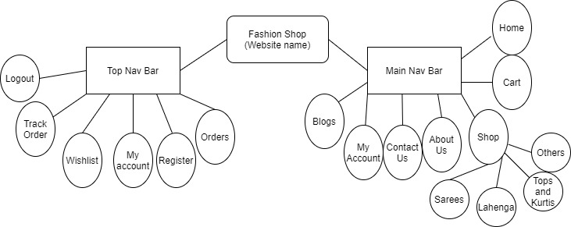

Software Requirements:

1. WordPress- I have Chosen the Ocean Wp Theme.
2. Plugins- I have used WooCommerce,Ocean Extra

Experimental Analysis:

During working on this project,I have analysed that many of the people are using Online shopping websites for ordering various products.There are many pros and cons of ecommerce websites.

Advantages:

### 1.Easy to Showcase Bestsellers

### 2.Personalized online experience

### 3.Sell Internationally

### 4.Easier to encourage impulsive buys

### Disadvantages:

1.E-commerce is highly competetive

2.Customers can be impatient

3.Shipping times can be lengthy

4.There is no trials before purchase

Result:

This is the home page for my website.

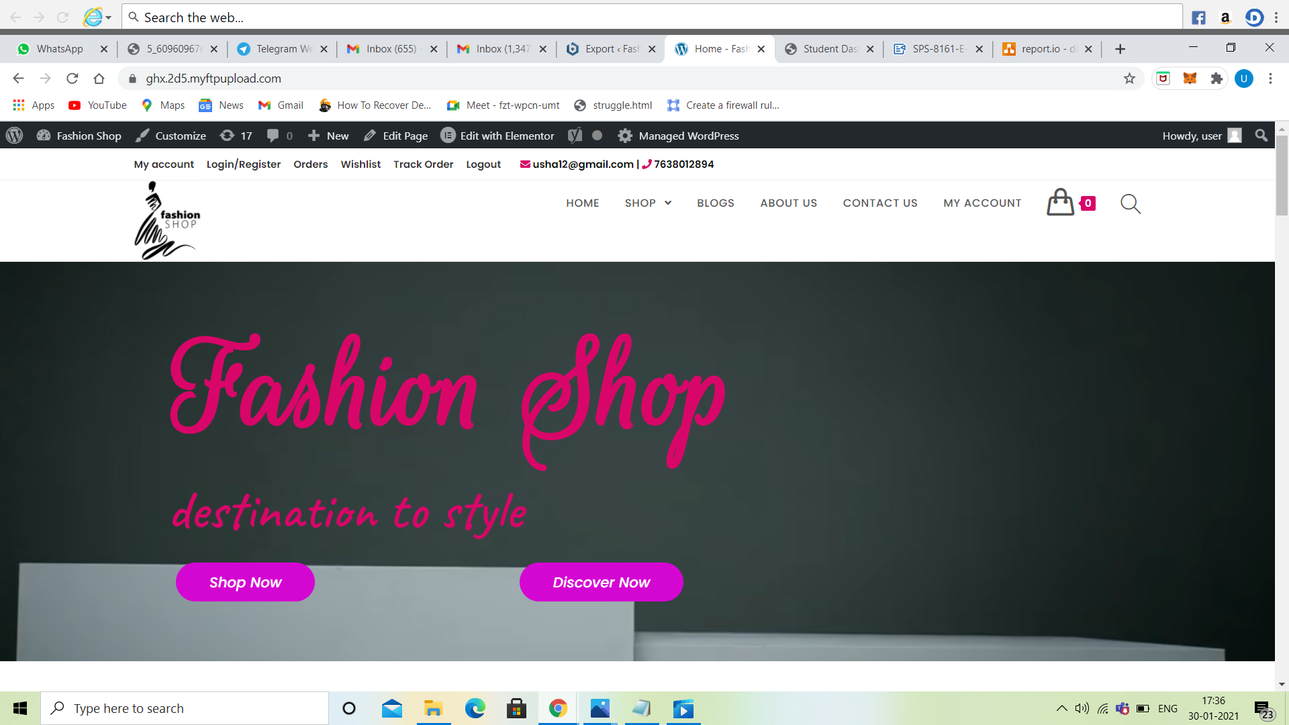

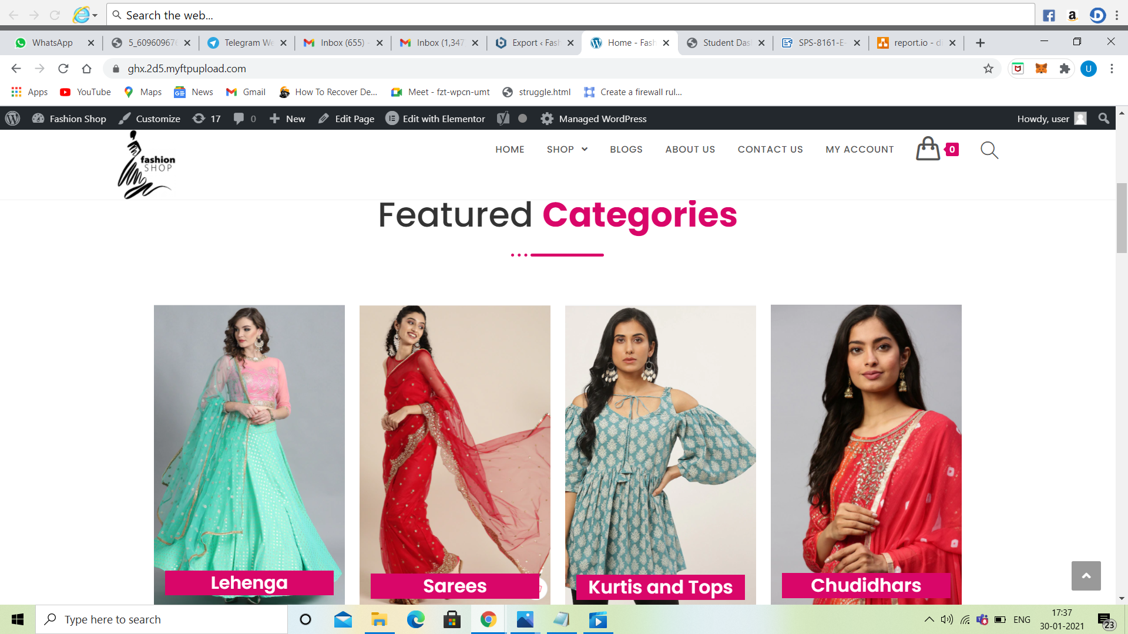

Shop page for my website.

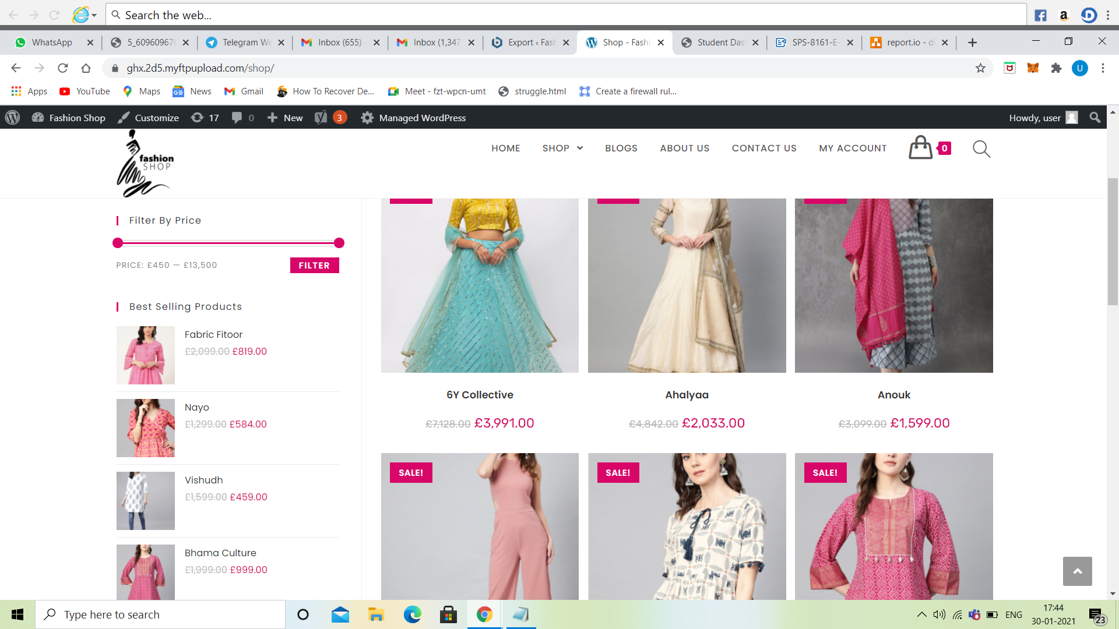

About Us page for my website

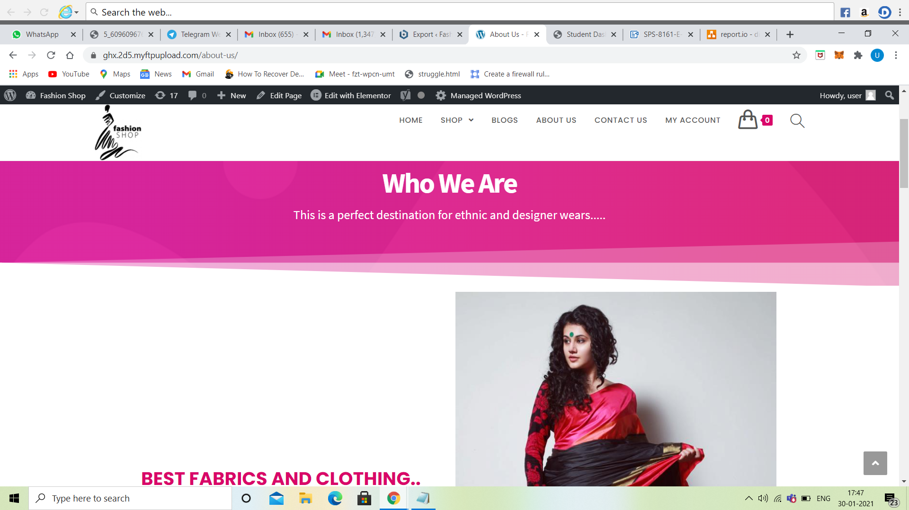

Contact Us page for my website

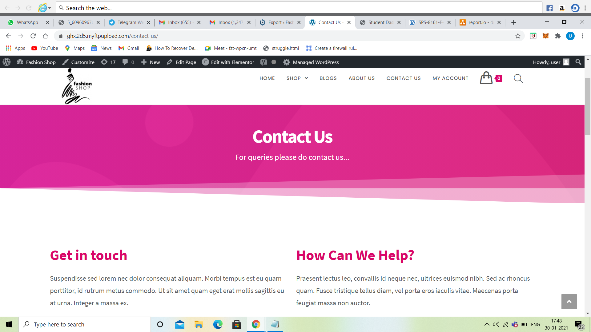

Applications:

Various applications of E-commerce websites are grocery supplies, internet bookshops, shopping sites for dress,etc made the life easier for buying various products without travelling or visiting the shop from anywhwere. Cash Payments , tax payments, bill payments have also become easier due to tjis e-commerce sites.

Conclusion:

So with this I conclude that e-commerce websites is the best place for various online shoppings and payments.

Future Scope:

In future E-commerce experience will become more personalized, it will include lot more relevant contents and will shift towards better service and elevate the shopping experience.

Bibliography:



<https://youtu.be/MFgZ5Vm-LU8>



<https://youtu.be/DYmf4pBmluo>

.